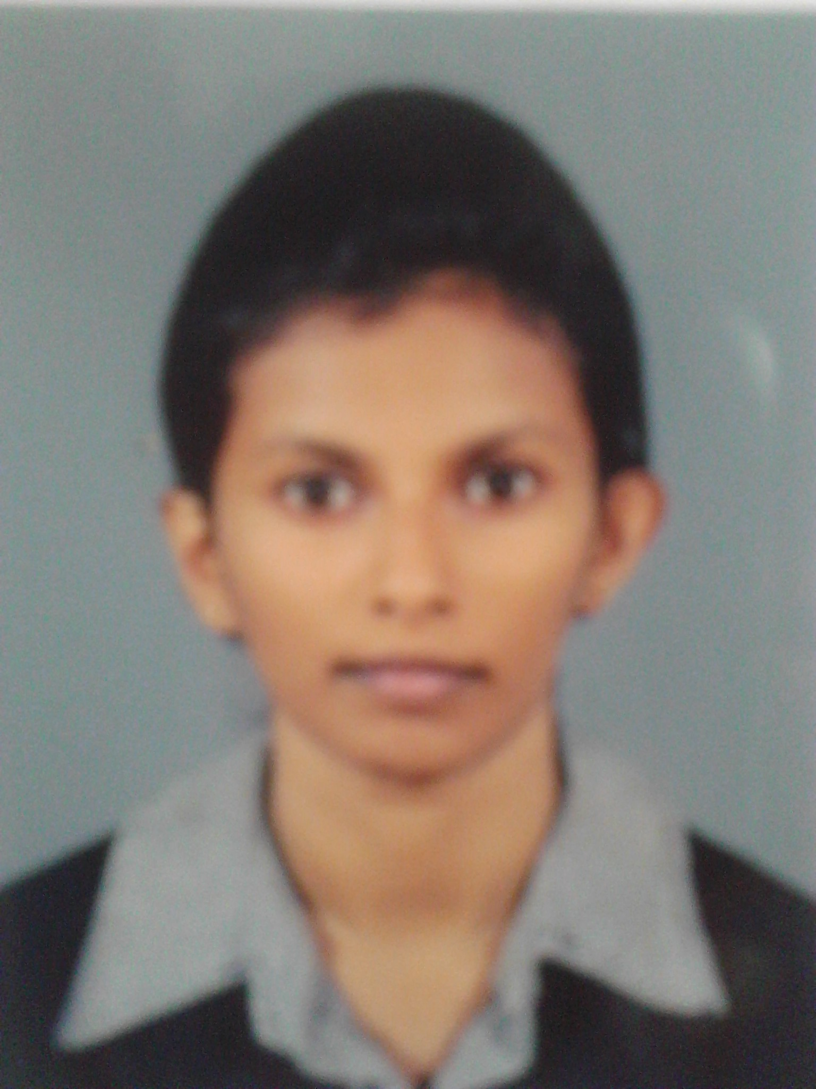
CURRICULUM VITAE

W.P.M.Prasadhika
Grama Niladari Office,Kirimatithanna, Balangoda
T.P. 071 5383764
E-mail - Madu.prasadi91@gmail.com

PERSONAL DETAILS

- Name in Full : Wijenayaka Patirathnalage Maduwanthi Prasadhika
- Name with Initials : W.P. Maduwanthi Prasadhika
- Date of Birth : 04.05.1991
- Religion : Buddhist
- Nationality : Sri Lankan
- Civil Status : Unmarried
- Gender : Female
- N. I. C. No : 916252790V
- Temper Address : No.81, Bunt Rd, Hedala, Wattala.

EDUCATION QULIFICATION
G. C. E. Ordinary Level in 2007- R/Ananda Maithreya National School, Balangoda

Subjects Grade
Buddhism A
English A
Sinhala B
Home sciences B
Social Studies B
Mathematics B
Dance C
Science C
English Literature C

G. C. E. Advanced Level in 2010- R/Ananda Maithreya National School, Balangoda

Subjects Grade
- Sinhala A
- Political Science A
- Logic A
- English C

Higher Education, Undergraduate in University of Colombo, Sripalee Campus. (BA (sp) Mass Media)

OTHER QULIFICATION

Successfully completed the certificate course in Computer Resource Center, Balangoda Zone . Following Courses are

- Graphic Design And Animation
- Web Design
- Office Appilication

EXTRA CURRICULA ACTIVITIES

- Completed the Leader ship training program, held by The Ministry of Higher Education.
- Member of Vision press club in university of Colombo, Sripalee Campus.
- Won first place in easy competition. Held by SWO( Saviya Women Organization) and SDF (Saviya Development Foundation) on 2011
- Won 3rd place in easy competition. Held by Balngoda Ananda Maitreya Central College on 2010
- I was a member of School Prefect in year 2008-2010.
- I was a member of School Net Ball Team in year 2005-2010.
- I was a member of Buddhist Association in year 2005-2010.
- I Was a member of Media Unit in 2008-2010

STRENGTHS
- Capable to cope up with new system upgrades easily.
- Highly reliable and responsible pertaining to the matters of work.
- Performance oriented and hardworking.
- Resourceful and believes in continuous learning and improvement.
- Good at team working.
NON REFEREES

- Mr. R.M. Thushan Lakamal Bandara
BM – Pettah (Singer Plus)
Peoples Park, Pettah

- Mr. Shan Wijethunga
Senior Manager in TISL
NO 5/1 , Eli Bank Rd, Colombo 06

I can assure you that the above information furnished about me is in perfect truthfulness and can be proved at any time required.

